**Pipe and Redirection Operators**

**1.Create a script named “myscript” in current directory to do the following.**

**A) Create a dir named “subd1” in current directory**

Ans:pwd

ls

vi myscript.sh [mkdir subd1(#!/bin/sh-Insert mode-:wq)]

bash myscript.sh

ls

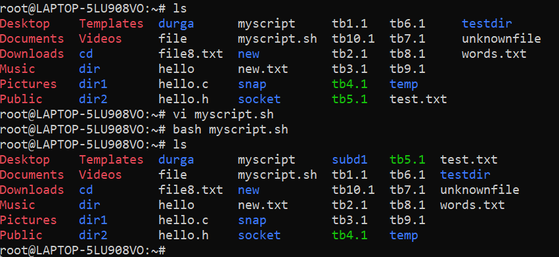

b)create a file named “dircontent” with contents of the current directory

Ans:

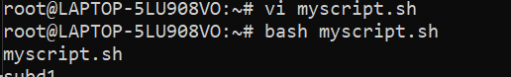

c) Display the contents of the file “dircontent”

Ans:



d) Display the contents of a non existing file named “unknownfile”

Ans: cat unknownfile

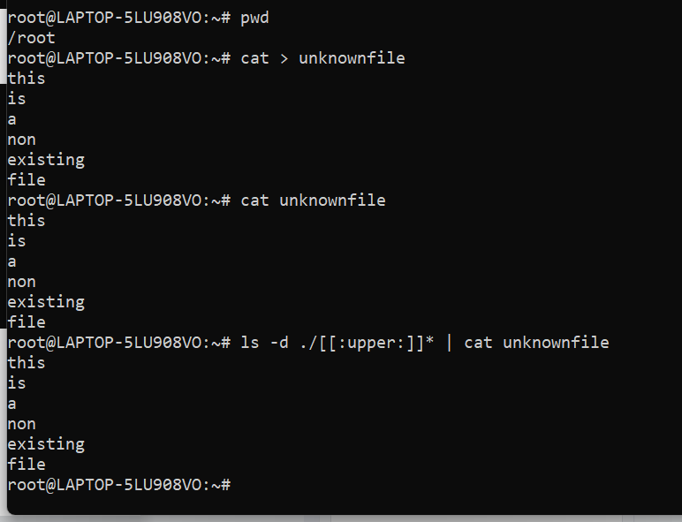

2.Run the script and validate the output in following cases

a)Redirect only the stdout to an o/p file named stdout.txt

Ans:

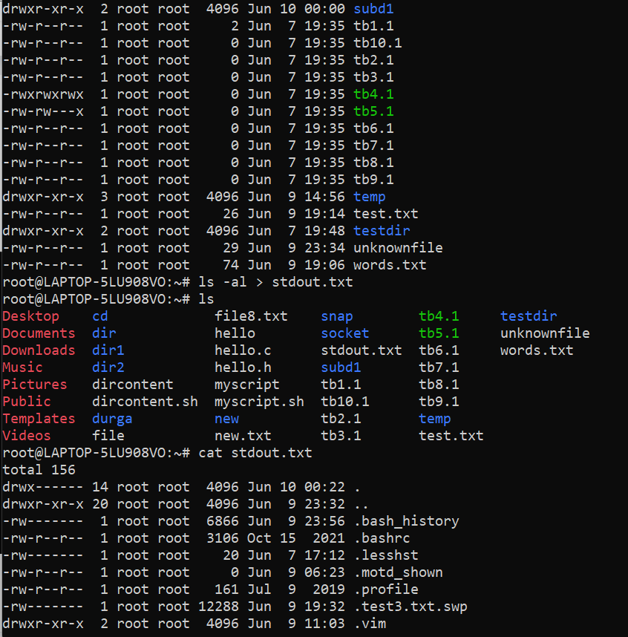

b)Redirect only the stderr to an o/p file named stderr.txt

Ans:

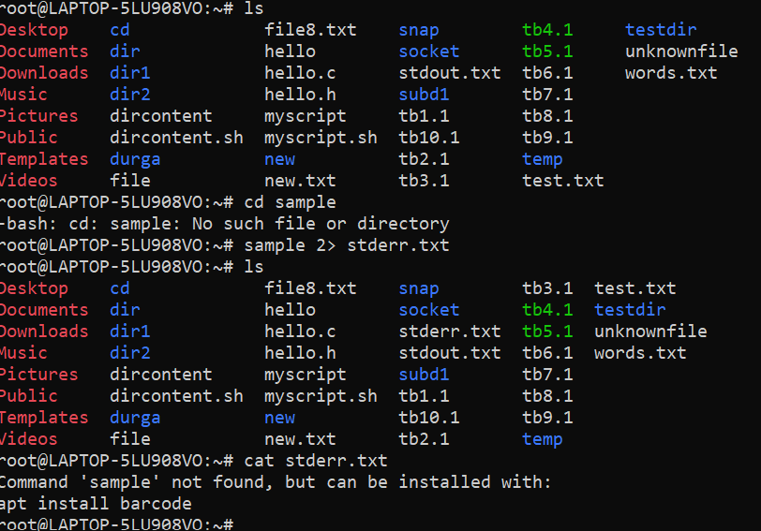

c)Redirect both stdout and stderr to an o/p file named stdall.txt

Ans:

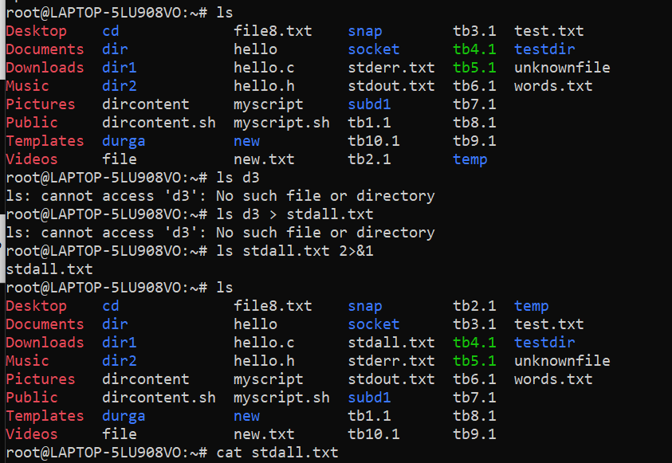

d)Display all o/p and error and also redirect both stdout and stderr to an o/p file named stdall.txt

Ans:

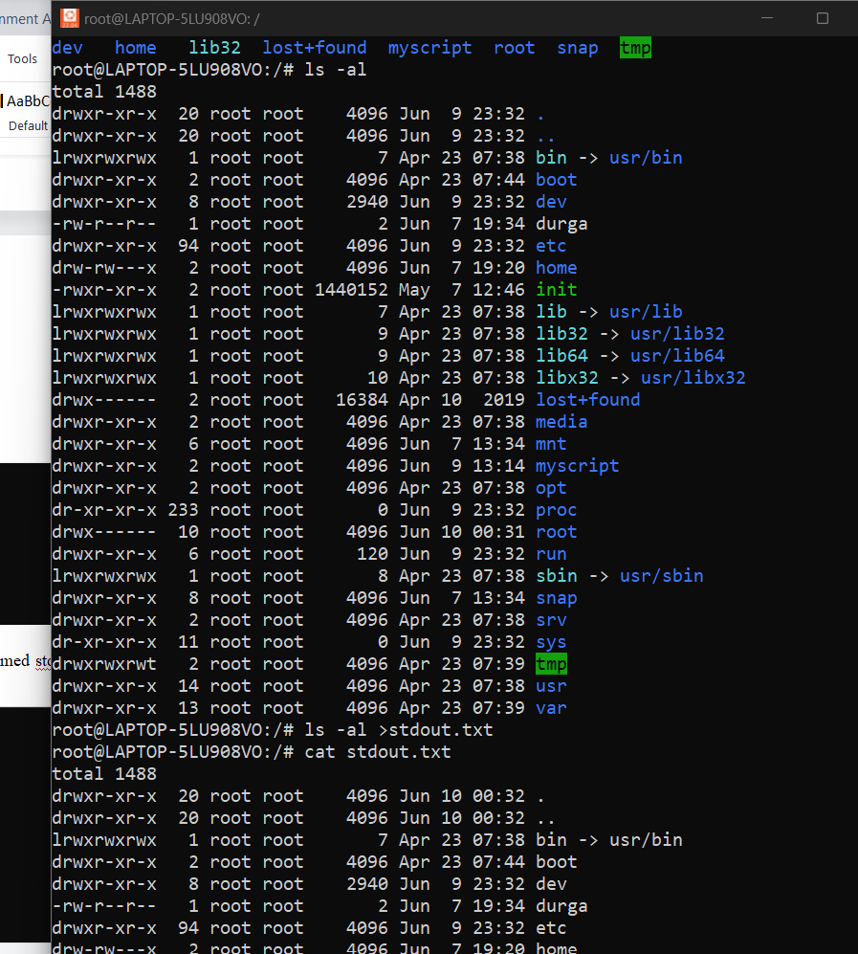

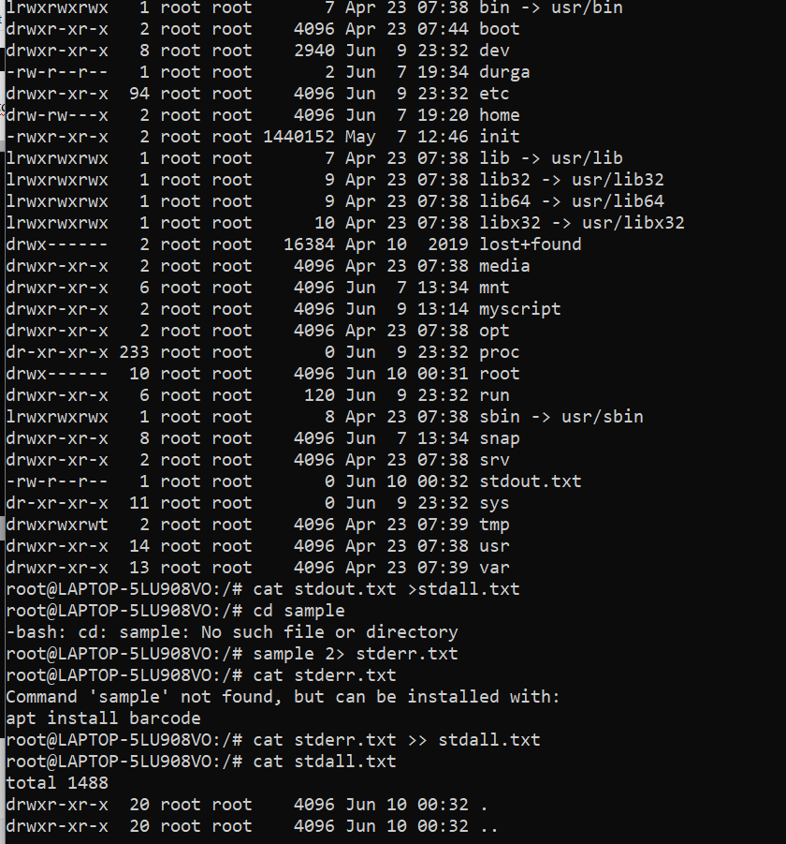

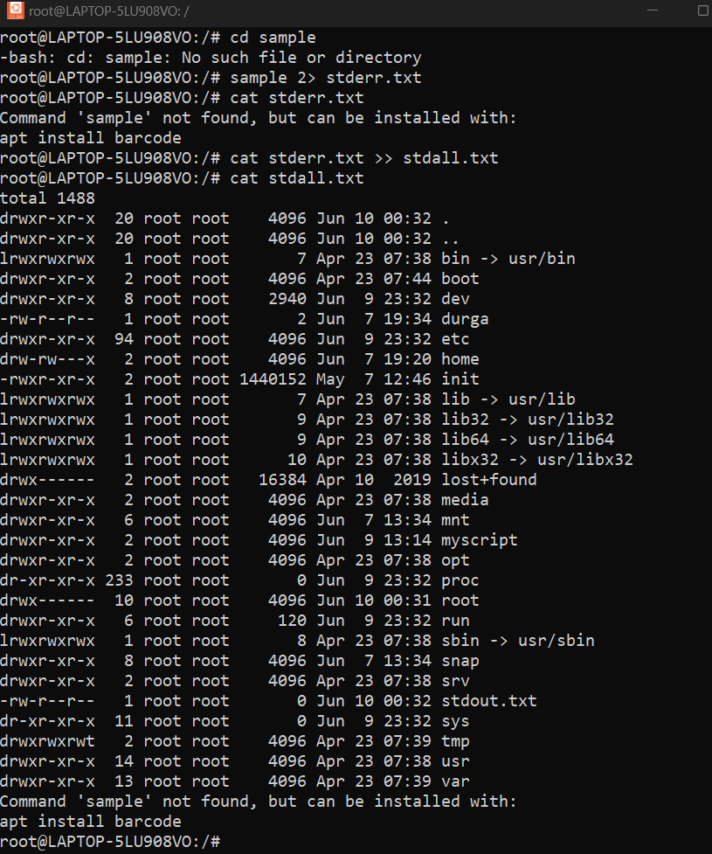

3.Redirect the output of command below using pipe (|) to wc and get the output .

ls -l

Ans:

